**Industrial Internship Report on**

**”Departments and its Details”**

**Prepared by**

**G.Nashrath**

|  |
| --- |
| *Executive Summary* |
| This report provides details of the Industrial Internship provided by upskill Campus and The IoT Academy in collaboration with Industrial Partner UniConverge Technologies Pvt Ltd (UCT).  This internship was focused on a project/problem statement provided by UCT. We had to finish the project including the report in 6 weeks’ time.  My Project is on **App Development** in which I have made so many small apps in which I had choose a app for my Final project Report.  This internship gave me a very good opportunity to get exposure to Industrial problems and design/implement solution for that. It was an overall great experience to have this internship. |

**TABLE OF CONTENTS**

1 Preface 3

2 Introduction 4

2.1 About UniConverge Technologies Pvt Ltd 4

2.2 About upskill Campus 8

2.3 Objective 9

2.4 Reference 9

2.5 Glossary 10

3 Problem Statement 11

4 Existing and Proposed solution 12

5 Proposed Design/ Model 13

5.1 High Level Diagram (if applicable) 13

5.2 Low Level Diagram (if applicable) 13

5.3 Interfaces (if applicable) 13

6 Performance Test 14

6.1 Test Plan/ Test Cases 14

6.2 Test Procedure 14

6.3 Performance Outcome 14

7 My learnings 15

8 Future work scope 16

# Preface

Summary of the whole 6 weeks’ work.

About need of relevant Internship in career development.

Brief about Your project/problem statement.

Opportunity given by USC/UCT.

How Program was planned

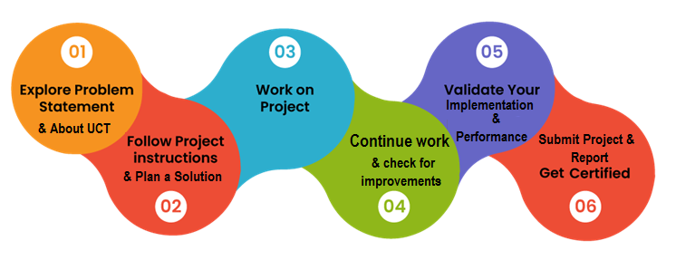

Your Learnings and overall experience.

Thank to all (with names), who have helped you directly or indirectly.

Your message to your juniors and peers.

# Introduction

## About UniConverge Technologies Pvt Ltd

A company established in 2013 and working in Digital Transformation domain and providing Industrial solutions with prime focus on sustainability and RoI.

For developing its products and solutions it is leveraging various**Cutting Edge Technologies e.g. Internet of Things (IoT), Cyber Security, Cloud computing (AWS, Azure), Machine Learning, Communication Technologies (4G/5G/LoRaWAN), Java Full Stack, Python, Front end**etc.

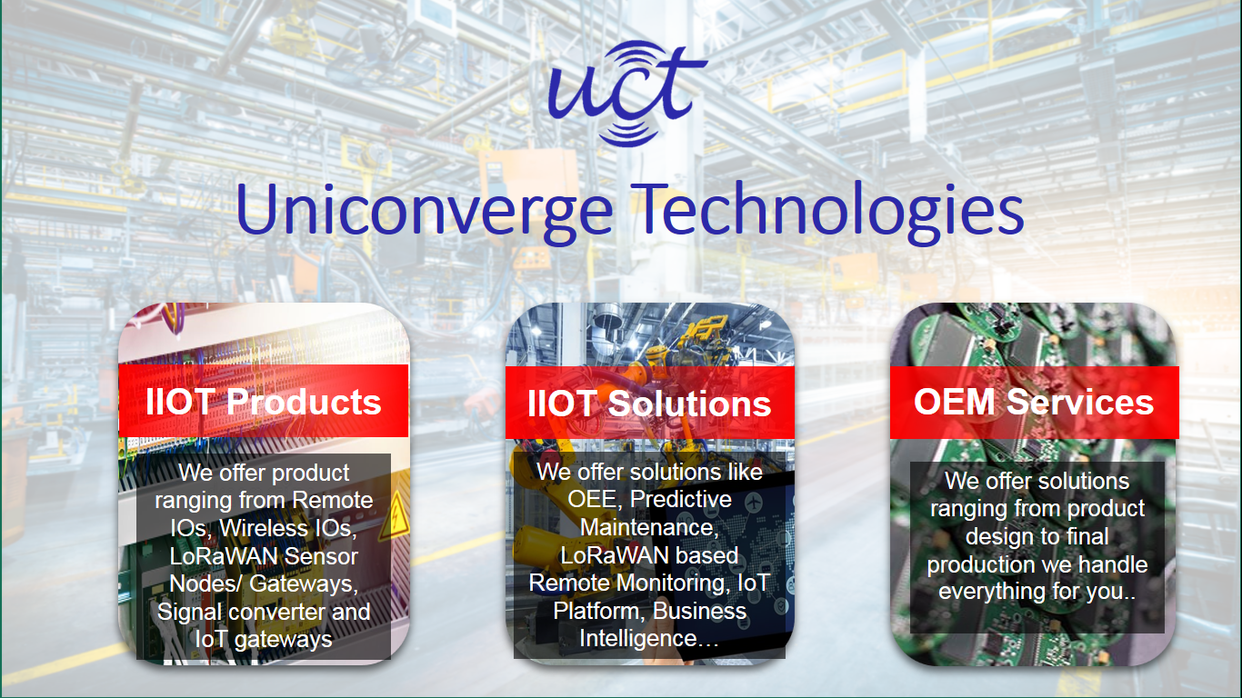

1. UCT IoT Platform **(****)**

**UCT Insight** is an IOT platform designed for quick deployment of IOT applications on the same time providing valuable “insight” for your process/business. It has been built in Java for backend and ReactJS for Front end. It has support for MySQL and various NoSql Databases.

* It enables device connectivity via industry standard IoT protocols - MQTT, CoAP, HTTP, Modbus TCP, OPC UA
* It supports both cloud and on-premises deployments.

It has features to  
• Build Your own dashboard  
• Analytics and Reporting  
• Alert and Notification  
• Integration with third party application(Power BI, SAP, ERP)  
• Rule Engine

 

1. **Smart Factory Platform (****)**

Factory watch is a platform for smart factory needs.

It provides Users/ Factory

* with a scalable solution for their Production and asset monitoring
* OEE and predictive maintenance solution scaling up to digital twin for your assets.
* to unleased the true potential of the data that their machines are generating and helps to identify the KPIs and also improve them.
* A modular architecture that allows users to choose the service that they what to start and then can scale to more complex solutions as per their demands.

Its unique SaaS model helps users to save time, cost and money.

 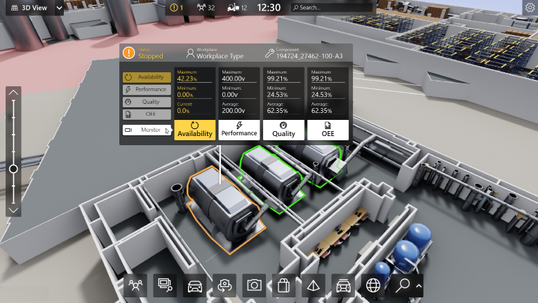

1. 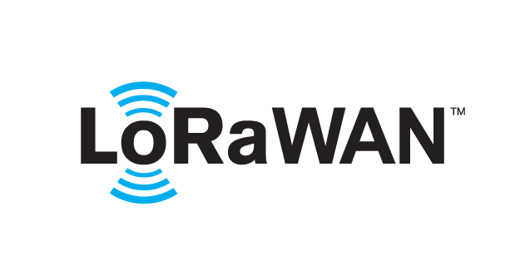 based Solution

UCT is one of the early adopters of LoRAWAN teschnology and providing solution in Agritech, Smart cities, Industrial Monitoring, Smart Street Light, Smart Water/ Gas/ Electricity metering solutions etc.

1. Predictive Maintenance

UCT is providing Industrial Machine health monitoring and Predictive maintenance solution leveraging Embedded system, Industrial IoT and Machine Learning Technologies by finding Remaining useful life time of various Machines used in production process.



## About upskill Campus (USC)

upskill Campus along with The IoT Academy and in association with Uniconverge technologies has facilitated the smooth execution of the complete internship process.

USC is a career development platform that delivers **personalized executive coaching** in a more affordable, scalable and measurable way.



Seeing need of upskilling in self paced manner along-with additional support services e.g. Internship, projects, interaction with Industry experts, Career growth Services

<https://www.upskillcampus.com/>

upSkill Campus aiming to upskill 1 million learners in next 5 year

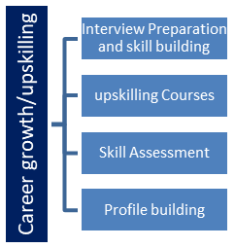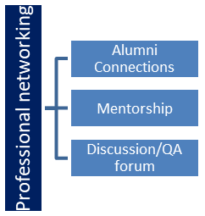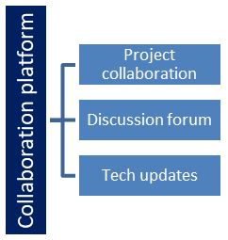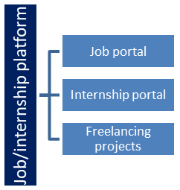

## The IoT Academy

The IoT academy is EdTech Division of UCT that is running long executive certification programs in collaboration with EICT Academy, IITK, IITR and IITG in multiple domains.

## Objectives of this Internship program

The objective for this internship program was to

 ☛ get practical experience of working in the industry.

 ☛ to solve real world problems.

 ☛ to have improved job prospects.

 ☛ to have Improved understanding of our field and its applications.

 ☛ to have Personal growth like better communication and problem solving.

## Reference

[1] Through Linkedln

[2] Reference from friend

[3] Through College Email Id

# Problem Statement

I got soo many Errors while Doing Project and I have solved it by Referring in the Notes and Lectures.

# Existing and Proposed solution

## Code submission (Github link)

https://github.com/nashrath/RelativeLayout/commit/32f08cf27c0cfaebf25a4ea7865e02c5b9b8c4a4#diff-0c4bccf9fa27e847ccd85bdd8a8de44c9cd0622f6fcf874b9744abc52ba15b72

## Report submission (Github link) :

https://github.com/nashrath/RelativeLayout

# Proposed Design/ Model

1: This picture Referes to code for Main Activity XML, Which contain only Spinner.

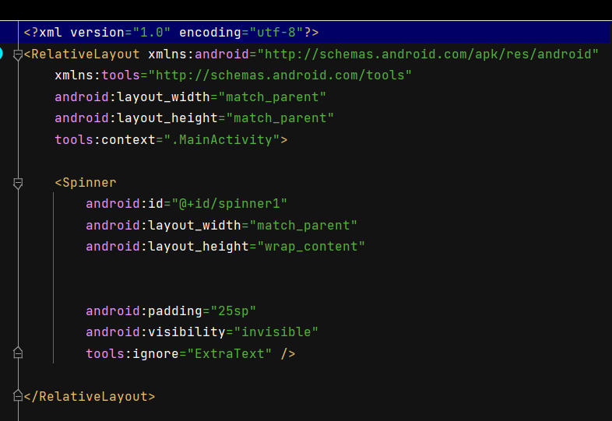

2: This Picture Refers for Java Code for Main Activity.

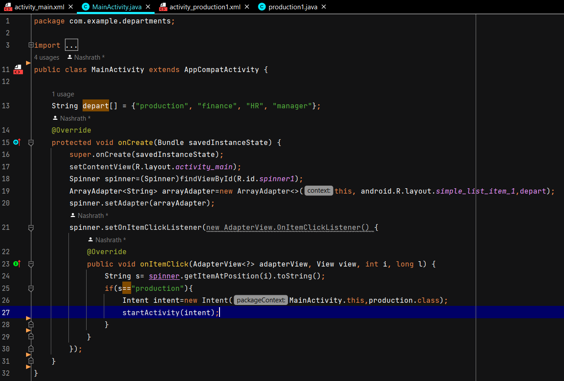

3. This Figure Shows about XML code for next page.

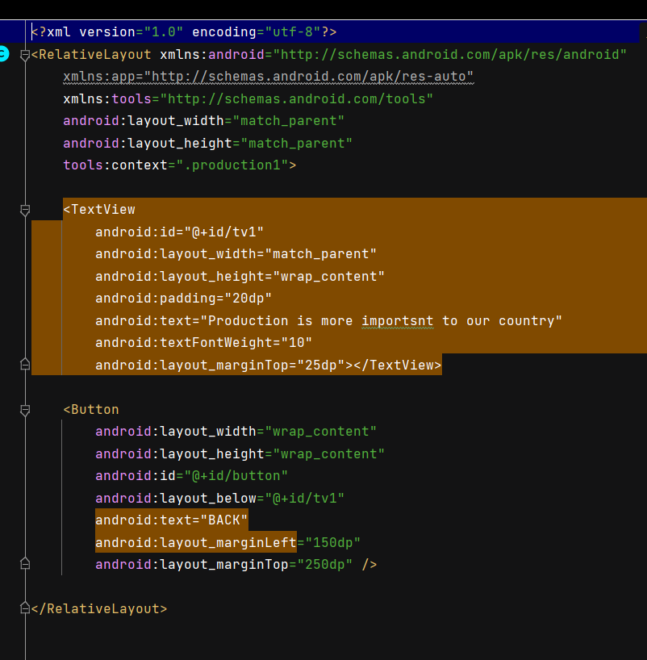

4: This Figure shows the design of the Next page.

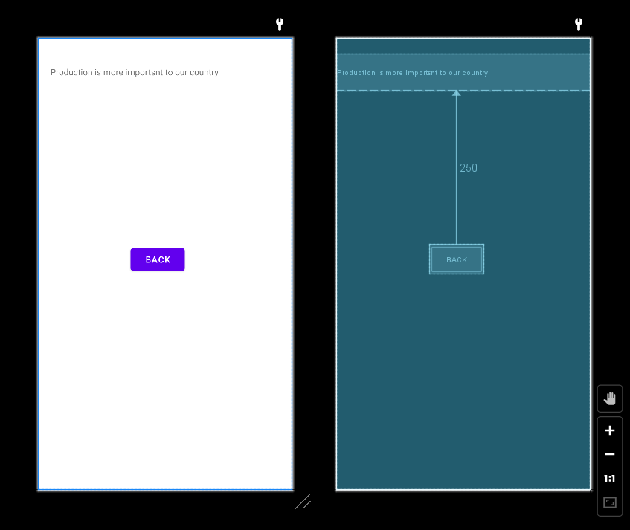

5: This Figure Shows Java Code For the Next Page.

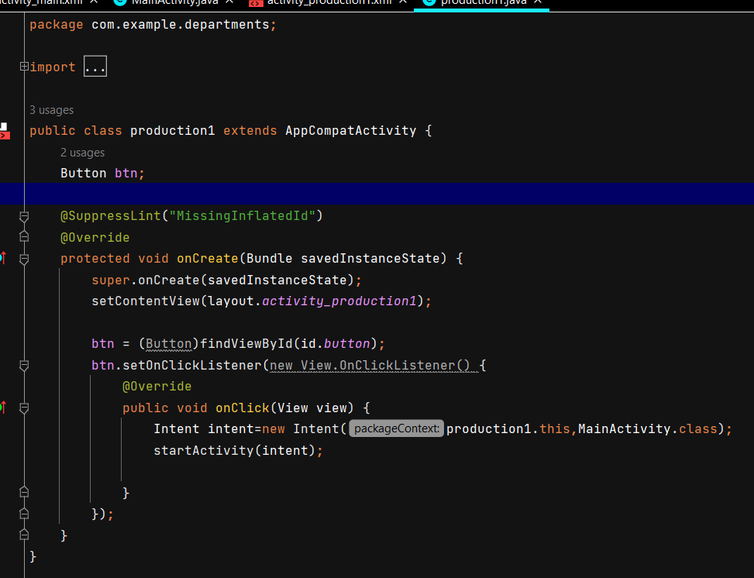

# Performance Test

Performance testing can involve quantitative tests done in a lab or in production environments. In performance tests, requirements should be identified and tested. Typical parameters include processing speed, data transfer rates, network bandwidth and throughput, workload efficiency and reliability.

## Test Plan/ Test Cases

At first I have Plan a Design and make sure it has to check after Implementation and started working on it,and while doing the project I had faced a lot of errors and I solved with the help of Previous Notes and Lectures.

## Performance Outcome

I got the correct Output which I expect and I have Created an App on Departments and its fretures.

# My learnings

A App Development internship can mark the beginning of a new career. To prepare for this next phase of my professional life.

With so many Real-life examples had made us to understand so well in a proper manner.

As videos are recorded one, so that one who can’t understand the topic can able to refer the videos again.

Clear road map had provided.

A very good opportunity for beginners like us.

Apart from videos, links and pdfs had provided.

Clear explanation. And also it is better for us if you provide some basic concepts of programing languages which are needed for App Development.

Through IoT academy everyone can gain the knowledge. best platform for beginners and learners too.

# Future work scope

In the realm of app development, creating a digital solution that meets the present needs of users is merely the first step in a dynamic and ever-evolving journey. The trajectory of a successful app is not only determined by its current functionalities but by its adaptability and continuous improvement over time. The concept of future work scope in app development encompasses a proactive strategy that involves anticipating user expectations, integrating emerging technologies, and enhancing the overall user experience.

Anticipating User Needs: An app's value lies in its ability to cater to users' changing needs and preferences. As an app gains users and garners feedback, the future work scope involves leveraging this insight to introduce new features or refine existing ones. This process entails a delicate balance between innovation and user familiarity. Features that resonate with users today might not hold the same appeal tomorrow. By anticipating these shifts, developers can ensure that their app remains relevant and in tune with the evolving landscape.

Incorporating Emerging Technologies: The technological landscape is in constant flux, and staying at the forefront of innovation is a crucial component of future app development. Emerging technologies like augmented reality (AR), virtual reality (VR), artificial intelligence (AI), and blockchain have the potential to revolutionize user experiences. As part of the future work scope, app developers must evaluate the feasibility and relevance of integrating such technologies to enhance functionality, engagement, and differentiation.